**Right Click Menu User Guide**

UnCLAD

# ABOUT

This XControl is used for replacing system right click menu. Programmer can configure the style of right click menu, such as font name, font size, font color, separator color, frame color and overlay color. All the contents (menu items) of right click menu are corresponding with *.rcm file which programmer can create/edit it by using RCM Editor. Programmer could create different *.rcm files for each control and pane, then launch specified *.rcm when controls or panes’ mouse down event has been activated.

# EXAMPLE-1: HOW TO CREATE/EDIT *.RCM FILE

In this exercise, you will learn how to create/edit *.rcm file which use for defining the structure of menu items.

1. Create a new blank VI;

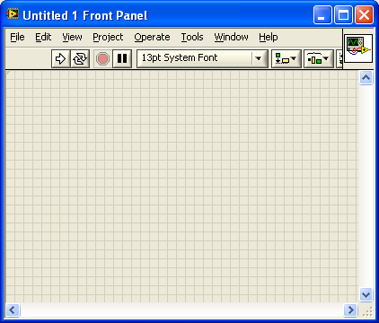

2. Drag Right Click Menu XControl to the front panel of this VI;

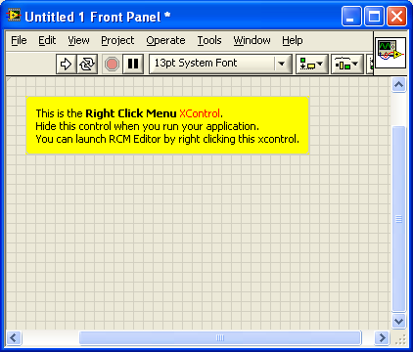

3. Right click XControl, you will find “Launch RCM Editor” on right click menu, then select it;

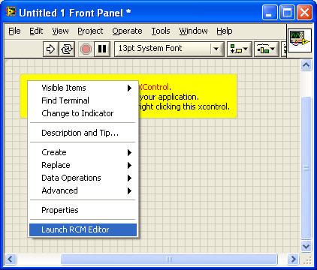

4. The GUI of RCM Editor will be shown as below, you can create new or open an existed *.rcm file;

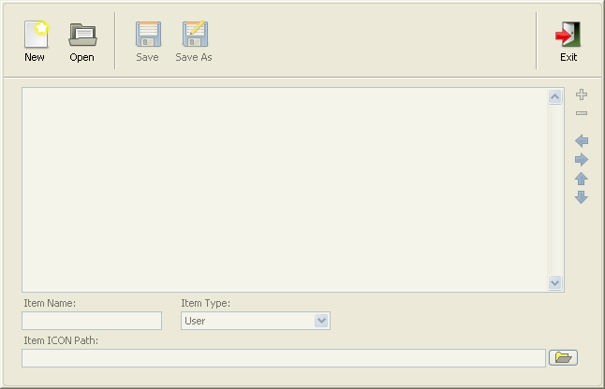

Buttons on Menu Bar:

|  |  |
| --- | --- |
|  | Create a new file. |
|  | Open an existed file. |
|  | Save file. |
|  | Save file as. |
|  | Exit RCM Editor. |

Buttons for Item Manipulation:

|  |  |
| --- | --- |
|  | Add a new menu item. |
|  | Remove menu item. |
|  | Outdent menu item. |
|  | Indent menu item. |
|  | Upward menu item. |
|  | Downward menu item. |

5. Press “New” button to create a new *.rcm file;

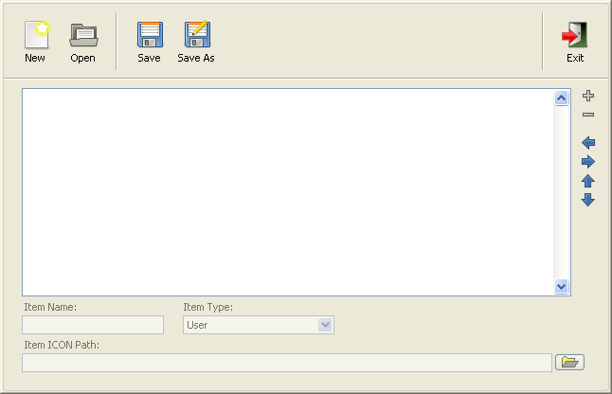

6. Press “Add” button to add a new menu item;

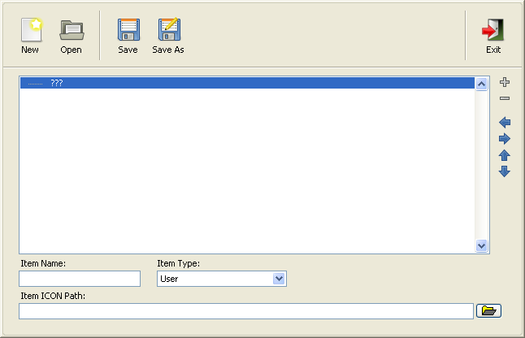

7. Type “Menu 1” to Item Name, you also can specify icon* for this menu item;

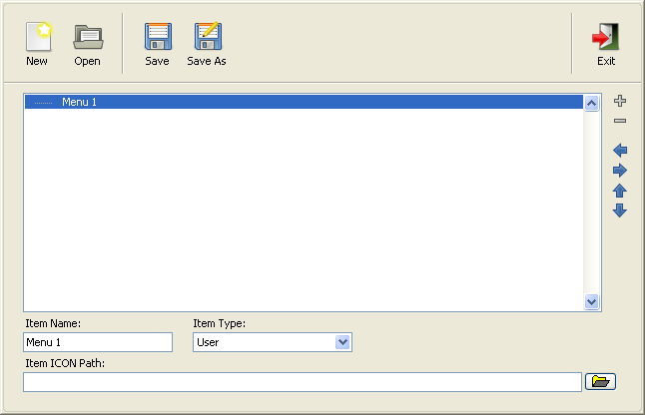

*Support 16x16 image file only.

8. Press “Add” button to add a new menu item, and type “Menu 1-1” to Item Name, then press “indent” button;

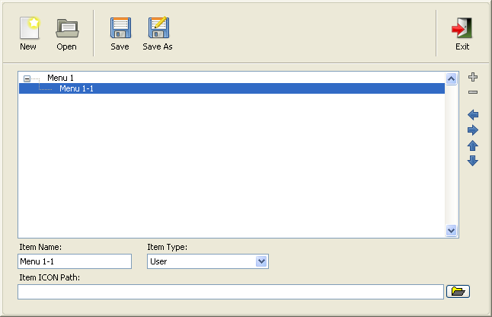

9. Press “Add” button to add a new menu item, and type “Menu 1-2” to Item Name;

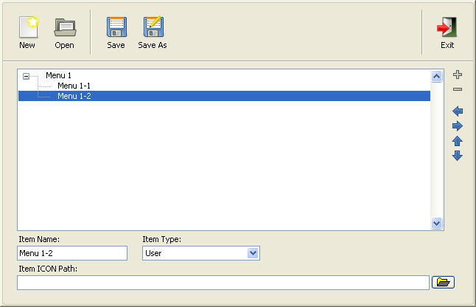

10. Select “Menu 1” item, then press “Add” button to add a new menu item, and type “Menu 2” to Item Name;

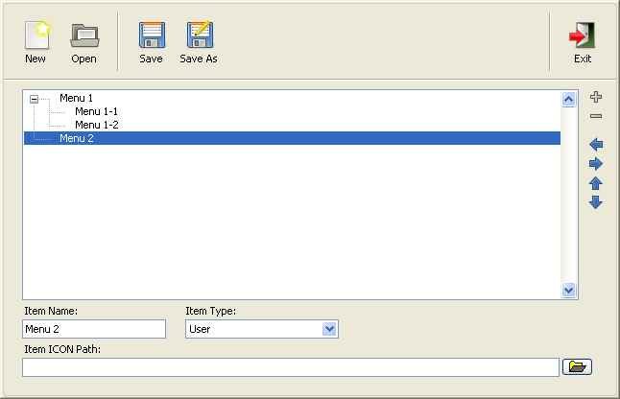

11. Press “Add” button to add a new menu item, and select Item Type to “Separator”;

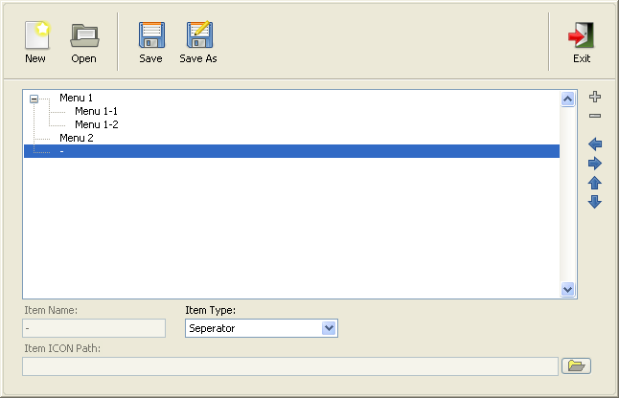

12. Press “Add” button to add a new menu item, and type “Menu 3” to Item Name;

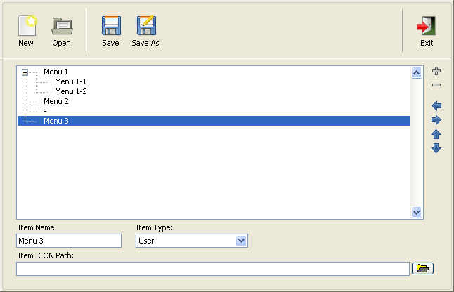

13. Press “Save” button to save *.rcm file as “temp.rcm”;

14. Press “New” button to create a new *.rcm file, then press “Open” button to open “temp.rcm” and check it.

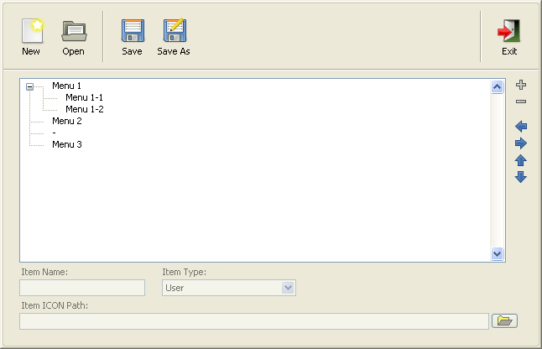

15. Now you can edit “temp.rcm” file by pressing each item.

|  |  |
| --- | --- |
|  | Using specified item name to define shortcut. |
| “_”: _Menu 1 will be shown as Menu 1; |
| “@”: @Menu 1 will be shown as (M)enu 1. |

# EXAMPLE-2: HOW TO USE RCM XCONTROL

In this exercise, you will learn how to create an application with Right Click Menu XControl.

1. Open a blank VI;

2. Set your font panel as bellow;

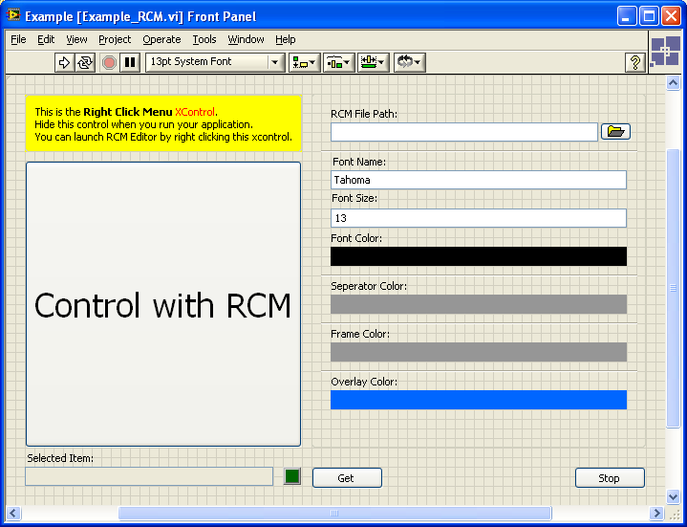

3. Using event loop structure for this example VI;

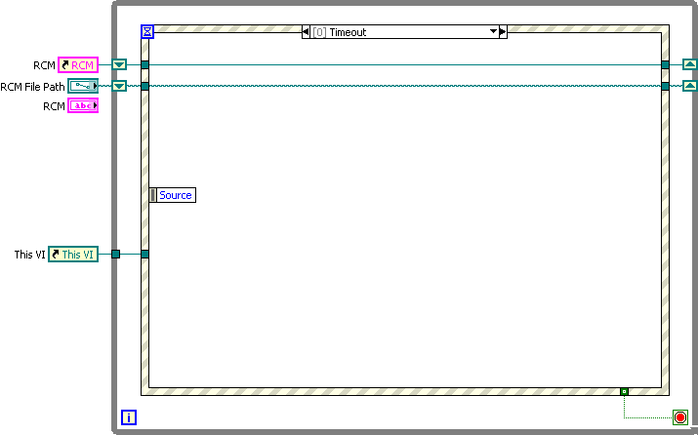

4. Create “Mouse Down” event for the control which you want to use right click menu, use “Start RCM With Parameters” invoke node for right button of mouse and “Stop RCM” invoke node for others;

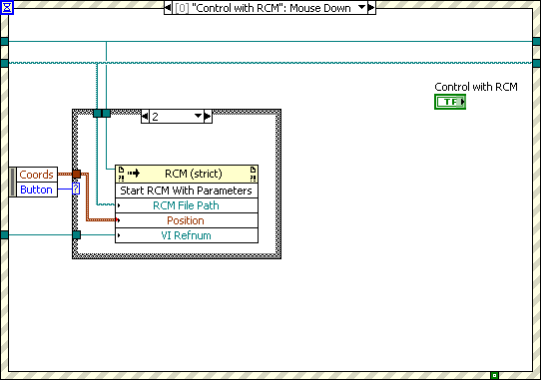

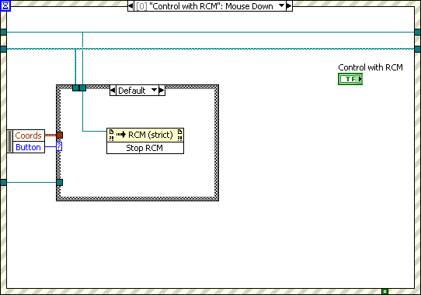

5. Create “Value Change” event for RCM File Path control as bellow:

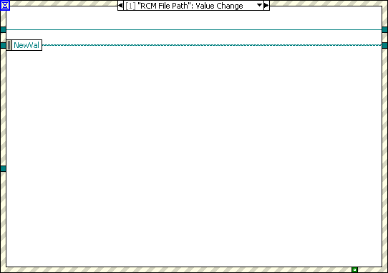

6. Create “Value Change” event for Font Name control as bellow, use “RCM Font: Name” property node for applying state changed:

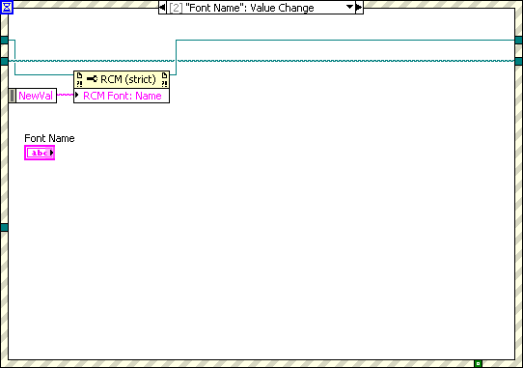

7. Create “Value Change” event for Font Size control as bellow, use “RCM Font: Size” property node for applying state changed:

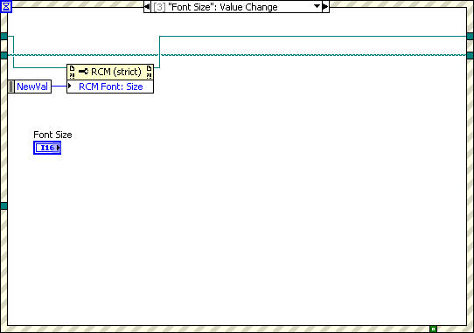

8. Create “Value Change” event for Font Color control as bellow, use “RCM Font: Color” property node for applying state changed:

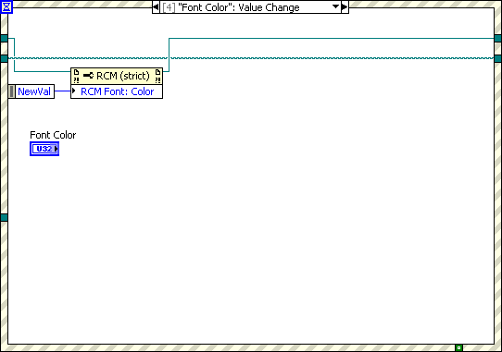

9. Create “Value Change” event for Separator Color control as bellow, use “RCM Separator Color” property node for applying state changed:

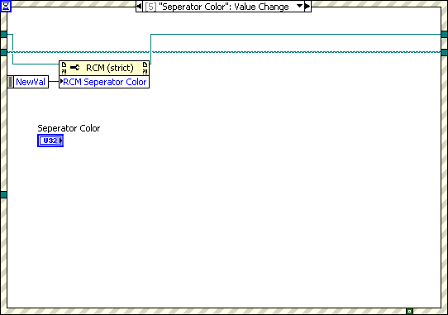

10. Create “Value Change” event for Frame Color control as bellow, use “RCM Frame Color” property node for applying state changed:

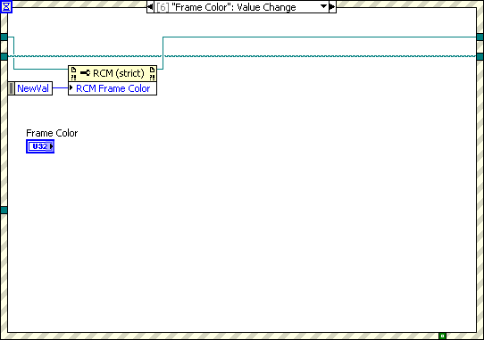

11. Create “Value Change” event for Overlay Color control as bellow, use “RCM Overlay Color” property node for applying state changed:

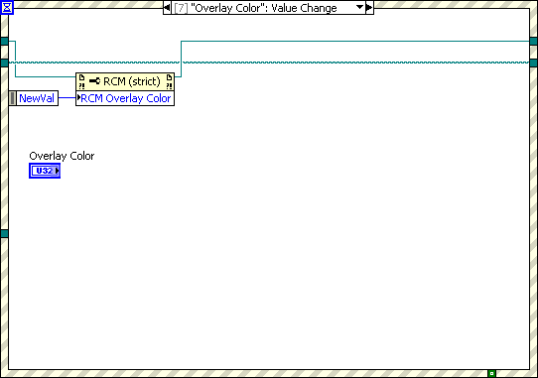

12. Create “Mouse Down” event for pane, use “Stop RCM” invoke node for dispose right click menu when press mouse on pane:

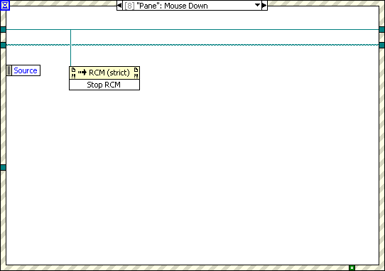

13. Create “Value Change” event for Get control, use “Get Selected Item Name” invoke node for getting selected item name and selected status;

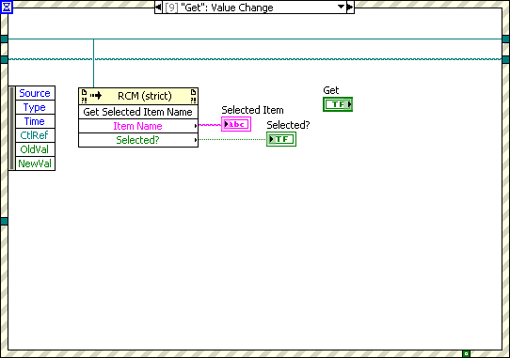

14. Add “Value Change” event for Stop control to stop application.

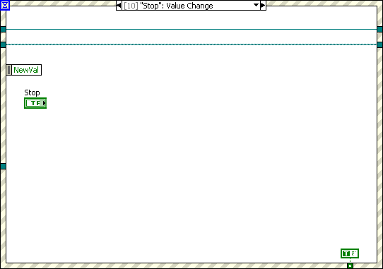

# EXAMPLE-3 HOW TO USE EXAMPLE

In this exercise, you will learn how to use example to show right click menu.

1. Run example;

2. Select a *.rcm file;

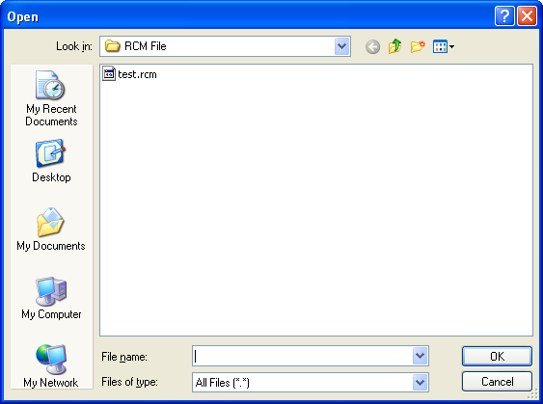

3. Right click boolean control to show menu;

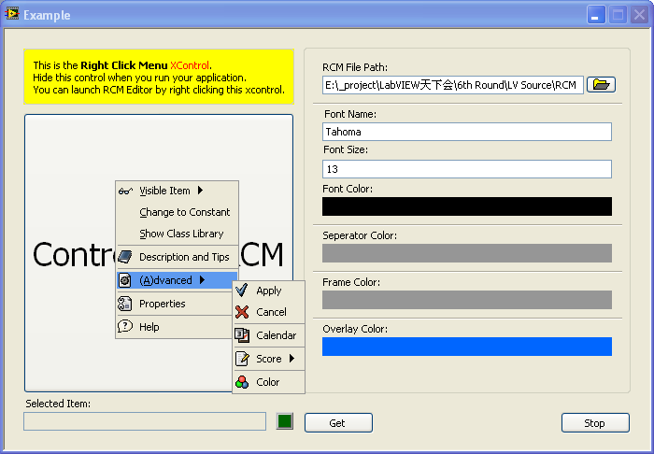

4. Try to change properties of right click menu then right click boolean control to show it;

5. For different menu structure, you can use different *.rcm file.